7of SPECIAL EVENTS:

DO WE KNOW HOW TO PARTY OR WHAT…

**Sunday, January 5, 2014 WHITE ELEPHANT SALE**

**STARTS 1PM COME EARLY**

**Piano music 1 pm Meeting 2**

**It was our best holiday party ever as our fun-loving club gathered for all the things we love best- music, mayhem, munchees, margaritas and morchids (more orchids- can you ever have too many? NO!) The food was glorious thanks to the creativity and generosity of our members. A special thank you to Dan Mumau, Mike Lawless & Carol Siegel for the prime rib, Gloria & Mike Gunn for the pork roast, Betty &John Williams for the ham, Cathy & Jim Loftfield for the pork loin, Wanda & Bruce LaFollette for the lovely salmon, Cathy and Bruce Weber for the turkey, Joel Davidson for the fried turkey, and Cathy Lindsay for the shrimp & me, too, for the music, margarita machine, paper goods, champage, drinks, tinsel hair, photo booth and nail artists, key chains, and candy buffet. Thanks to everybody who brought delicious eats. Through the generosity of our members, we were able to donate five cartons of canned goods to the Salvation Army. How nice of us! Michael Shane delighted us on keyboard, and we drank umpteen bottles of champagne and frozen margaritas. The Joy Squad took zany pictures of us in our photo booth to take home.Daring members got tinsel in their hair (don’t ask), and even the fearless men got orchids painted on their nails. We walked around with blinking necklaces, hair extensions, and santa hats, and we were honored for all we had done wth orchid key chains. If you missed getting one, pay your dues and you can have one, too. We had 100 blooming beauties from Hilo Orchid Farm for our raffle, and Tony and Ole got us LOTS of orchids and gorgeous poinsettias from the hotels. Orchids& champagne and orchid art… doesn’t get any better.**

**2014**

**THE GREATER LAS VEGAS ORCHID SOCIETY**

**THE ORCHID COLUMN**

**CAROL SIEGEL, EDITOR**

January 5, 2014

Ron Parons “Orchids of China”

February 2, 2014

Diana Smith “Orchids 101”

March 2, 2014 Sean Abbott “Growing

Phalaenopsis”

March 29, 2014 W Charleston Library

“A Passion for Orchids” Show 10-4

April 6, 2014

Ron Kaufmann “Orchids at the Beach”

May 4, 2014 Shelly North Barbecue

June 1, 2014 Peter Lin “Orchids for

Every Day of the Year”

July 13, 2014

Alan Koch “Orchids 101”

August 3,2014 Diana Smith“Coelogyne”

September 7, 2014 Harold Koopowitz’

“A Fantastic Voyage Through Paphs”  
October 5, 2014 Greenhouse Tour

November 2, 2014 Carol Siegel

“Tools of the Orchid Grower”

December 7, 2014 Holiday Party

January 11, 2015 !! Fred Clarke

“Aussie Dendrobium”

It

Congratulations to Cathy Loftfield, recipient of the

2013 Diamond Award of Excellence from Orchid Digest for all her fine work for our club. Way to go!

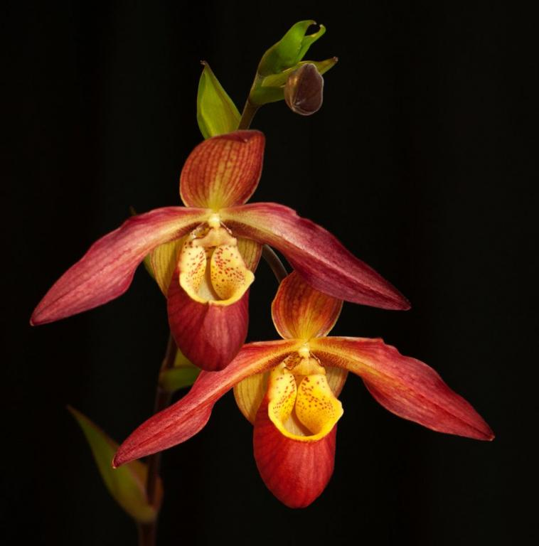

**CLUB DUES FOR 2014**

**ARE DUE NOW…**

**PAY AND GET AN**

**ORCHID KEY CHAIN**

key.gif

Thank you to all the folks who paid 2014 dues at the party. (We liquor you up and then ask for money… not so dumb…) Some folks even added a small donation. Diana and I did! Dues remain $30 for individual or $45 for couples (two people at same addres). **You can pay at the January meeting or send a check to me made out to GLVOS: Carol Siegel 8601 Robinson Ridge Drive Las Vegas, NV 89117.** I pay for the newsletter postage myself so if you have an email, please tell me. Mine is [growlove@cox.net](mailto:growlove@cox.net). If you have decided not to rejoin, please let us know. If you join, we will give you one of our colorful orchid keychains. We have not raised dues in many years, but if you are able to include an extra few dollars, we would be most grateful.

Our lovely keychains for 2014 feature the club name GLVOS, 2014, and a lovely *Phragmipedium* orchid which I think is *Phrag* Noirmont (*Phrag longifolium x Phrag* Mem. Dick Clements). *Phragmipedium* are slipper orchids that are found only in the New World. They love to be wet. They often have long moustache-like petals with a lip that curves inward. The name comes from the Greek *phragma* which means “division” and *pedium* which means “slipper” referring to the pouch shape.

WHITE ELEPHANT SALE IN JANUARY…

LOTS OF ORCHIDS FOR YOU $10

**It’s time once more for our annual white elephant sale, JANUARY 5, an event that earned OVER $1000 last year. COME EARLY SO YOU CAN SET UP AND BROWSE AND BUY. ONE O’CLOCK WOULD BE GOOD! We are a very high-class club, and our junk is of the very best quality. Everyone brings in some unwanted treasure- wine, a holiday gift, a lamp, a bike, books, CD’s, VHS’s, DVD’s, dishes, pictures, nick nacks, sporting equipment, food…Don’t have anything elephantine? Bring an orchid or orchid stuff or a division from your collection or Home Depot. I bought orchids that I am going to donate. You could, too. Start looking around. I wrote to some nurseries and got them to donate orchids to our club. We will pay the postage. Last year, we asked the the kind people at Piping Rock Orchids, Sunset Valley Orchids, Hilo Orchid Farm, Andy’s Orchid, Cal Orchids, Orchid Limited, Orchids by Hausermann, Zuma Canyon Orchids and Santa Barbara Orchids for orchids, and I will ask them again this year.. We will also ask Orchids of Los Osos, Norman’s Orchids, Carmela’s Orchids and Repotme. We will sell them for $10. Very exciting. Don’t forget to bring in your White Elephant Items. We thank our White Elephant Captains in adavance- the Tuthills, Webers, Williams, Kings,Myra Glassman, Christina de la Cruz and the LaFollettes. Thanks to Nita Bragg, Rae Kurtz, Kathy Lindsay, Stella Charvet, Lee Kirshbaum and Sharon Proehl for food in January. We still need two or three kind souls to sign up for food in February.**

**C:\Documents and Settings\Rick\Local Settings\Temporary Internet Files\Content.IE5\VKQHUYPQ\MC900441570[1].wmf**

At our January 5 meeting, **Ron Parsons**, photographer extraordinaire, will do a presentation on “**The Orchids of China**.” In Ron’s words:

“In 2013 I made my second trip to the province of Sichuan (known to most Americans as Szechwan) in China. In 2012 I went with my co-author, Mary Gerritsen on a tour led by slipper orchid specialist Holger Perner and his wife, Wenqing, to see various Cypripedium species (the temperate species of slipper orchids, found only in the northern hemisphere, and generally in colder climes).

I enjoyed that so immensely, so we signed up again for the 2013 tourIn 2013 I made my second trip to the province of Sichuan (known to most Americans as Szechwan) in China. In 2012 I went with my co-author, Mary Gerritsen on a tour led by slipper orchid specialist Holger Perner and his wife, Wenqing, to see various Cypripedium species (the temperate species of slipper orchids, found only in the northern hemisphere, and generally in colder climes) from June 09-23. I enjoyed that so immensely, so we signed up again for the 2013 tour, from June 17- July 01 to see these amazing orchids at different sites this time. We saw a good number of various orchids as well as numerous other beautiful flowers and amazing scenery. This talk will feature the beauty of China seen on this trip. to see these amazing orchids at different sites this time. We saw a good number of various orchids as well as numerous other beautiful flowers and amazing scenery. This talk will feature the beauty of China seen on this trip.

Mark Romansky has created a Facebook page for us. Type in “Greater Las Vegas Orchid Society” or click on <https://www.facebook.com/glvos>. Be sure to write a comment or tell us about you, your orchids or the club. People really do take the social media seriously, and, even if you are not a big fan of Facebook, at least visit it once to give us a bigger presence on the web. Alex McKyton, our webmaster, maintains our website. It has a new address [www.glvos.org](http://www.glvos.org).Take a look. It has information about our club and copies of our newsletters. Many members have told us they have found us from our website.

**cattleya dowiana.gif**



**LOOKING BACK AT 2013….**

It is hard to believe that 2014 is already here. We had a fantastic year. Pardon us as we strut our stuff, 2013 style. Looking back, the big news is that we love the Rainbow Library, the best meeting room ever. Smart people just wander in, and we just leave these new members. We have a beautiful room, totally dark presentations, a kitchen, piano music on a baby grand, and even security. We really learned a lot last year and had great fun. We continued our electronic newsletter. Some of us even bloomed some of our orchids, which always is a miracle in this scorching hot, brutally dry desert. We attracted lots of new members and made new friends. I provided live piano music on our baby grand with the very talented Dennis Sullivan.We advertised in newspapers, on TV, on flyers, in the RJ, and on meetup.com. We had fabulous speakers who entertained and informed us and sold lovely and interesting plants. We learned to buy plants for the meeting that someone might actually want at a decent price, another miracle. We raffled off everything from house plants to trees to orchids to Ipads and marveled at Tony Billitere and Ole Borresen’s ability to walk away with so many great things from the hotels. Charm helps… We ate great food and laughed a lot. We had a website hosted by Alex McKyton and advertised on Meetup.com. Mark Romansky created a facebook page for us. We donated food to charities and participated in an orchid show. We arranged a new orchid show at the West Charleston Library on March 29th, and we arranged a new venue at Shelly North’s house for our barbecue. We had lots more people bringing in blooming beauties to show and tell and talking about them, too. Let us stroll back through 2013 and remember all we did together.

In January, we made over $1500 at our White Elephant Sale amid cries of “But what IS it?!!” as we lugged out more stuff than we brought in. We loved the 80 orchids in bloom that we scooped up donated by our nursery friends. Ron Parsons did a wonderful talk on miniature orchids. We had an ad on meetup.com and had a raffle for an IPad mini which made $300 for the club. The newsletter had an article I wrote published in Orchid Digest on orchid deception. We were proud to present an Orchid Digest Diamond Award of Excellent to Ole Borresen, Dan Mumau and Mike Lawless. A tribute to him was published in Orchid Digest.

In February, Ramon de los Santos did a wonderful talk on the 1200 orchid species of the Philippines and taught us how to grow them. We had lots of Valentine goodies and lots of Valentine gifts to give out. The newsletter had an article on growing *Catasetum.*

In March, Diana Smith delighted us with a presentation on *Catasetum, Mormodes and Gongora.* We sold lovely *Catasetum* provided by Sunset Valley Orchids. The Board provided a Chinese feast, and the newsletter had an article on the orchid show at the New York Botanical Garden.

In April, Karen Muir treated us to a talk on the fascinating genus *Maxillaria,* and the club sold *Masdevallia, Zygopetalum* and *Catasetum* provided by Diana.Paula Garrett, our own club horticulturist, took us on a glorious walk to Calico Basin to see our very own native orchid, *Epipactis gigantea.* We even caught pictures of its syrphid fly pollinating carrying its pollinia. Very exciting stuff. Shelly North led club members in creating a beautiful display at the Easter Show at the Cal with props provided by Dan and Mike. The newsletter had an article I had published in Orchid Digest, “Bateman, Skinner and the Kiddies.”

In May, Harry Phillips of Andy’s Orchids did a great talk on how to grow orchids and provided lovely plants to buy. The newsletter had an article on plants where you should not cut off the spike after blooming.

In June, we welcomed back our favorite Jason Fischer who spoke about the Australian Orchid Conference and the orchids of Australia. He, of course, brought his fabulous plants. The newsletter had an article I wrote on “Falling In Love All Over Again” and a funny orchid poem by Sue Fordyce.

In July, amid piano music on our Baby Grand Piano and lots of patriotic hats, necklace and paraphenelia, we had a fabulous potluck presented by everybody, and Alan Koch taught us all about miniature cattleya. He sold his wonderful plants.

In August, as the horrific fires finally were put out, we enjoyed a wonderful barbecue catered by Master Chefs Dan Mumau and Mike Lawless at the lovely home of the gracious Eldine Stevenson in Mt. Charleston. Cathy Loftfield and Diana Smith did a wonderful presentation on growing orchids. This is our last barbecue at Eldine’s house. We have so loved being there.

Thank you, Eldine.

In September, members Mary and Barry King, Cathy and Jim Loftfield, and Aaron Schave opened their lovely greenhouses to us and showed us how it is done with style and smarts in the desert. They stuffed us with food and information. The newsletter had a checklist for growing in the desert.

In October, Cathy Loftfield did a stand-out presentation as usual on “The Orchids of Guatemala”, with her gorgeous photos and lots of information. Dennis Smith played lovely piano music, and we had a pizza party and chocolate bar and went home smart, fat, and happy. The newsletter had funny orchid poems. Ole Borresen was honored by received the Orchid Digest Diamond Award of Excellence. The newsletter had an article Cathy wrote on growing in sphragnum moss.

In November, I did a new power point presentation on “Orchidmania: The Human History of Orchids,” the phenomenon that swept the world in the 19th century and made everyone crazy for orchids. We sold plants from Carmela’s orchids.. The newsletter had an article “A Short Course on Orchid Growing.”

In December, flashing with lights and laughing with margaritas, we ended the year, thanks to the dear Lord, once again with a festive holiday party. The newsletter had a Christmas orchid poem and an article on growing under lights. Cathy Loftfield made up an orchid banner, and we all were happy.

Here’s hoping that 2014 bring you and yours only the best.

Love Carol 254-4168 525-3714 [growlove@cox.net](mailto:growlove@cox.net)

An Orchid Prayer for the New Year

Carol Siegel

Oh, Lord above who holds us dear

Please let my orchids bloom this year.

Let my roots grow thick and my buds grow round

And let no ugly brown scale be found

Kindly put all the nursery cattleyas on sale

And don’t let me have to buy my orchids retail.

Make my plants all bloom right before our meeting

So lots of show and tell excuses I won’t be needing.

Try to make my orchids bloom with lots of flowers

So I won’t feel I have wasted all those darn watering hours.

Please don’t make all my plastic tags fall out

So the parentage of every orphan plant is in doubt.

Bless my orchids to wow with pink, yellow and red

And please prevent more of them from winding up dead.

May all this year have many blessings from aboveAnd may you all have blooms that you really love.

Let all my orchid friends be healthy and have no cares

But may all my orchids always be nicer than theirs.