THE GREATER LAS VEGAS ORCHID SOCIETY
THE ORCHID COLUMN

SUNDAY,NOV3,2013 1PM PIANO MUSIC 2PM MEETING Carol Siegel, Editor

CAROL SIEGEL, EDITOR

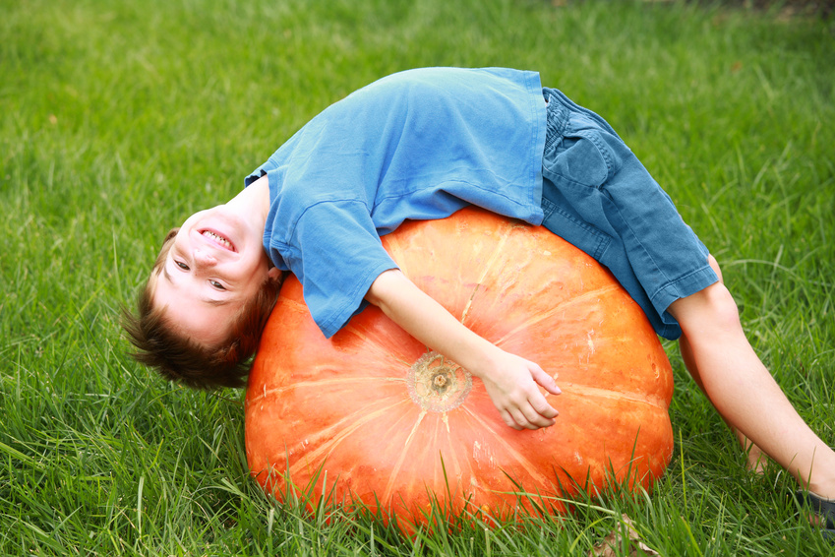SPECIAL EVENTS:
CAROL SIEGEL SPEAKS ON “ORCHIDMANIA- THE HUMAN HISTORY OF ORCHIDS” IN NOV

In the 19th century, the world went wild for orchids, and rich people paid as much as $100,000 for just one exotic orchids.
Fearless collectors braved tigers, cannibals, poisonous snakes, disease and unimaginable danger to bring them back.
Orchids were the ultimate status symbol, and the world went crazy for them. In this original power point presentation, I will tell the story of the people who fanned the fires of orchidmania including the Duke of Devonshire, Joseph Paxton, Frederick Sander, and Charles Darwin- as well as a weird and wild bunch of other orchid maniacs. We thank food angels Holly Bailey, Marlene Benedict, Mieko Magaki, Tricia Edwards-Schade, and Ingegard Rossan for the food for our meeting. Thanks to Eileen McKyton who has ordered orchids for sale from Carmela’s orchids. At 1pm, Dennis Sullivan will be providing live piano music, my treat.

Nov 3, 2013 Carol Siegel, “Orchidmania-
The Human History of Orchids”
December 8, 2013 Holiday Party 12:30
January 5, 2014 Ron Parsons
“Orchids of China”
White Elephant Sale
February 2, 2014 Fred Clarke
“Aussie Dendrobium”
March 2, 2014Diana Smith “Coelogyne”
March 29 10-4 “A Passion for Orchids”
West Charleston Library
April 6, 2013 Ron Kaufman
“Orchids at the Beach”
May 4, 2014 Barbecue Shelly North 12:30pm
June 1, 2013 Peter Lin
“Orchids for Every Day of the Year”
July 13, 2014 Alan Koch “Orchids 101”
August 3, 2014 Sean Abbot “Growing
Phalaenopsis”
September 7, 2014 Harold Koopowitz
“A Fantastic Voyage Through Paphs”
Oct 5, 2014 Diana Smith “Pests and Diseasesases”
November 2, 2014 Carol Siegel
“The Tools of the Orchid Grower”
December 7, 2014 Holiday Party
OCTOBER MEETIN
Our October meeting was great fun. We loved our pizza party from Pizza Hut, and club members went all out to provide fabulous chocolate treats for our unbelievable Chocolate Bar. Jesse Sander even brought an ice cream maker and made us incredible chocolate ice cream. The treats were so good that people started eating the chocolate immediately. Somebody told me to stop people from eating the chocolate. I said, “Not without a bulletproof vest.” (Who made me queen?) Not smart to get between a person and his chocolate… No rules… Just enjoy!

Dennis Sullivan played lovely live piano music, and Ole Borresen and Tony Billitere had wonderful hotel plants (We made $300 on the hotel plants. Thanks, gentlemen…) I bought slipper orchids from Lehua Orchids for the club to sell, and we sold every last one. Diana did an interesting little impromptu talk on orchid judging while we waited for our pizza. That girl can do anything…

We were most impressed and entertained by Cathy Loftfield’s presentation on “The Orchids of Guatemala.” Her extensive research, beautiful images, and lively presentation was much appreciated and enjoyed. I know how much work she put into it. Thank you, Cathy!

We welcomed a lot of wonderful new guests and members- Mark Cunningham, Mark Romansky, Gisela Radosavejevic, Marge Redman, Carolyn Jones, Mary Shapiro, Rosalie Shamir, Dallis Church, Don Gipe, and Jenny Kremer. We are thrilled to have you and hope you enjoy our club.

ELECTIONS
We will be holding elections at our November meeting. The current slate is:
Carol Siegel- President
Cathy Loftfield- Vice-President
Eileen McKyton- Secretary
Diana Smith- Treasurer

We welcome additional nominations. You can even nominate yourself, and we will second you. If you would like to make a nomination, contact Myra Glassman, our Election Chairman, at 256-1788 hotshrink@hotmail.com.

November 4, 2012
Carol Siegel “Liars and Cheats:
The Story of Orchid Deception”
December 2, 2012 Holiday Party
January 6, 2012
Ron Parsons “Miniature Orchids”
February 3, 2013
Alan Kochs “Unusual Species for the
Cattleya Grower”
March 3, 2013 Mike Glikbarg TBA
April 7, 2013 Karen Muir “Maxillaria”
May 5, 2013 Harry Phillips from Andy
Orchids “Mounted Orchids”
June 2, 2013 Jason Fischer
“Australian Orchid Conference”
July 7, 2013 Diana Smith “Catasetum”
August 4, 2013 Barbecue
Sept 8, 2013 Greenhouse Tour
October 6, 2013 Cathy Loftfield
“Orchids of Guatemala”

November 3, 2013 Carol Siegel
“Legends of theOrchid World”

HOLIDAY PARTY

ON NOVEMBER 4TH, I AM GOING TO SPEAK ON ‘LIARS AND CHEATS: THE STORY OF ORCHID DECEPTION.’ IT IS THE FASCINATING TALE OF
We are excited about our Holiday Party to be held at my home on Sunday, December 8nd at 12:30 pm. IT IS THE SECOND SUNDAY OF THE MONTH SINCE THE FIRST SUNDAY IS PART OF THE THANKSGIVING WEEKEND.My house is in Canyon Gate Country Club (which is opposite the Lakes) on Sahara between Durango and Ft. Apache. If you go west on Sahara, it is the first right after Durango (Canyon Gate Drive). There is a light. Make a right into the guard gate, say you are with the club. Make the firt right on Medalist and continue around for about a minute. The street, inexplicably, becomes Medalist, Iron Ridge and Robinson Ridge in a minute. I live at 8601 Robinson Ridge Drive. The house has a stained glass shell door. You can park on both sides of the street. I got permission from Homeowners. Everybody will bring a dish- side dish, dessert, vegetable, main dish for 10-12 with serving spoons, heated and cut up if necessary.
At our November meeting, we will have a few kind folks sign up for the meats. Dan Mumau, Mike Lawless and I will provide the prime ribs. We will need people to sign up for ham, pork loin, fish, turkey, fried turkey and the like. If you would like, you can email me and tell me what meat you can provide. growlove@cox.net I will provide paper goods, a margarita machine, champagne and wine and entertainment. I hired a new keyboard player and singer Michael Shane . We will have TWO ladies putting tinsel in hair, a photo booth, a nail artist, and lot of toys. I already have all the blinky flashing toys. I am excited! As is tradition the club will have a raffle where everyone will get a blooming orchids for $6.Hilo Orchids has agreed to provide our raffle plants for the party. It is always the most fun, a chance for us to have fun together and celebrate another successful year.

ORCHIDS WHERE THE REWARD GIVEN IS OFTEN JUST A DECOY AND NOT THE REAL MCCOY. 85% OF THE DECEIT FLOWERS IN THE WORLD ARE ORCHIDS, AND LYING HAS BECOME SOMETHING OF AN ORCHID FAMILY SPECIALTY. WHETHER IT IS LYING ABOUT HAVING NECTAR OR BEING A GOOD PLACE TO LAY EGGS OR A WILLING FEMALE, ORCHIDS ARE THE BEST BOTANICAL CHEATS IN THE WORLD. IN AUSTRALIA, NEARLY ALL THE TERRESTRIAL ORCHIDS ARE LIARS, AND IN PLACES LIKE EUROPE, NORTH AFRICA, AND THE MIDDLE EAST, OVER HALF OF THE ORCHIDS ARE FRAUDS.

A SHORT COURSE ON ORCHID GROWING

- BUY ORCHIDS THAT YOU DON’T THINK YOU WILL KILL. IF YOU KILL THEM, BUY SOME OTHER KIND. IF YOU KILL THAT, TOO, BUY MORE BOOKS BEFORE YOU BUY MORE ORCHIDS.

- IF YOU BUY OR WIN ORCHIDS THAT LIVE, BUY MORE OF THAT KIND OF ORCHID. IF THE ORCHID BLOOMS, BUY LOTS MORE OF THAT KIND OF ORCHID.

GATHER MORE INFORMATION THAN ORCHIDS. ASK QUESTIONS. LISTEN TO OTHER PEOPLE. READ BOOKS AND MAGAZINES. COME TO MEETINGS. SEE WHAT OTHER PEOPLE ARE ABLE TO GROW AND HOW THEY GROW THAT. LEARN.

- DO NOT COMPARE YOURSELF TO ANYBODY ELSE. THEY HAVE DIFFERENT AMOUNTS OF MONEY THAN YOU DO. THEY HAVE DIFFERENT AMOUNTS OF TIME THAN YOU DO. THEY HAVE A DIFFERENT GROWING AREA THAN YOU DO. SOMETIMES THEY LIE. SOMETIMES THEY JUST BOUGHT IT. DON’T BE TOO IMPRESSED. JUST KEEP TRYING. EVERYONE GETS BETTER, AND IF YOU KILL MOST OF YOUR ORCHIDS, THE ONES THAT SURVIVE WILL LOVE YOUR GROWING CONDITIONS. THAT’S GOOD…

- KEEP TRYING TO IMPROVE YOUR GROWING AREA. YOU ARE TRYING TO FOOL YOUR ORCHID INTO THINKING IT IS NOT IN THE DRIEST, HOTTEST, WORST PLACE TO GROW ORCHIDS. IF YOU DO NOTHING TO MAKE YOUR AREA MORE LIKE A MOIST, TROPICAL PARADISE, YOU WILL HAVE A HARDER TIME. ADD HUMIDITY. NOTICE YOUR LIGHT. PATROL FOR BUGS. BUY LOTS OF FANS TO MAKE THE AIR MOVE.

- SPEND AT LEAST 10 MINUTES A DAY WITH YOUR ORCHIDS. THEY ARE TRYING TO TELL YOU WHAT THEY WANT. IF YOU ARE IN THE VICINITY 10 MINUTES A DAY, YOU WILL GET BETTER AT HEARING THEM. YOU WILL SEE APHIDS, DRY SOIL, DAMAGED LEAVES, DISEASE. YOU WILL NOTICE FUNNY COLORED FOLIAGE OR BURNED LEAVES OR BROKEN DOWN SOIL. HANG OUT WITH YOUR ORCHIDS A LITTLE EACH DAY.

- WATER YOUR ORCHIDS A LOT. WE LIVE IN THE DESERT. WE DO NOT HAVE TO BE SO AFRAID TO GIVE OUR PLANTS WATER AND HUMIDITY. IT IS 2% HUMIDITY IN THE STREET AND MAYBE 25% HUMIDITY IN THE HOUSE. THESE GUYS LIKE 50-75% HUMIDITY. TRY TO GIVE YOUR PLANTS GOOD WATER- EITHER R/0, FILTERED WATER, DE-IONIZED WATER, OR POTASSIUM-ENRICHED WATER FROM YOUR WATER SOFTENER. DO NOT WATER WITH SALT-ENRICHED WATER FROM THE SOFTENER. IF YOU MUST USE TAP WATER, FLUSH WELL FROM TIME TO TIME TO REMOVE WHITE SALT BUILDUP.

- MAKE SURE THAT YOUR LIGHT VARIES WITH THE SEASONS AND THAT YOUR TEMPERATURE VARIES THROUGHOUT THE DAY AND NIGHT JUST LIKE IN NATURE. DO NOT GROW IN A ROOM WHERE IT IS ALWAYS 78 DEGREES AND THE LIGHT IS ON MOST OF THE TIME. NATURE IS NOT LIKE THAT. FIND SOMEWHERE WHERE IT IS DARK AT NIGHT AND COOLER IN THE EVENING LIKE A GUEST ROOM.

- DECIDE ON A GOAL FOR GROWING ORCHIDS. YOURS DOES NOT HAVE TO BE THE SAME AS MINE. I LIKE TO HAVE SOMETHING IN BLOOM ALL THE TIME. I LIKE TO WRITE ABOUT ORCHIDS. MAYBE YOU WANT TO HYBRIDIZE ORCHIDS OR GROW SPECIES. MAYBE YOU WANT TO HAVE AN ORCHID LIBRARY. MAYBE YOU WANT TO JUST HAVE LUNCH AT AN ORCHID MEETING OR HAVE AN ORCHID FOR YOUR TABLE. YOU DO NOT HAVE TO HAVE 300 ORCHIDS. YOU CAN JUST LEARN ABOUT ORCHIDS AND BUY A FEW FOR YOUR TABLE. THERE ARE NO RULES- JUST FUN.

- YOUR PROBLEMS ARE NOT UNIQUE. EVERYONE KILLS ORCHIDS AND HAS BUDS THAT BLAST AND PHALS THAT ROT. EVERYONE BUT A VERY BIG LIAR HAS PLANTS THAT SULK AND DO NOT BLOOM, SO WHAT!! KEEP TRYING. YOU WILL HAVE MORE AND MORE SUCCESS. YOUR ORCHIDS WILL LEARN TO LIVE WITH YOU AND YOUR BENIGN NEGLECT& WILL BLOOM FOR YOU AT LAST,
I have attached to the newsletter email a reprint of my article on Bateman and Skinner. Cathy’s wonderful talk on the orchids of Guatemala brought up a discussion of the two men who were most important in bringing the orchids of Guatemala back to Europe, James Bateman and George Ure Skinner. If you are interested, the article speaks about the contribution of these two great men.

Wishing you all the best,
Love Carol 254-4168 growlove@cox.net

(256-1788). WE WILL SECOND YOU!

PRESIDENT CAROL SIEGEL
VICE PRESIDENT CATHY LOFTFIELD
SECRETARY EILEEN MCKYTON
TREASURER DIANA SMITH

ATTACHED TO THE NEWSLETTER ARE THREE POEMS BY THE VERY TALENTED (AND FUNNY) SUE FORDYCE

