THE GREATER LAS VEGAS ORCHID SOCIETY
THE ORCHID COLUMN

SEPTEMBER 9, 2012 2PM GREENHOUSE TOUR

CAROL SIEGEL, EDITOR

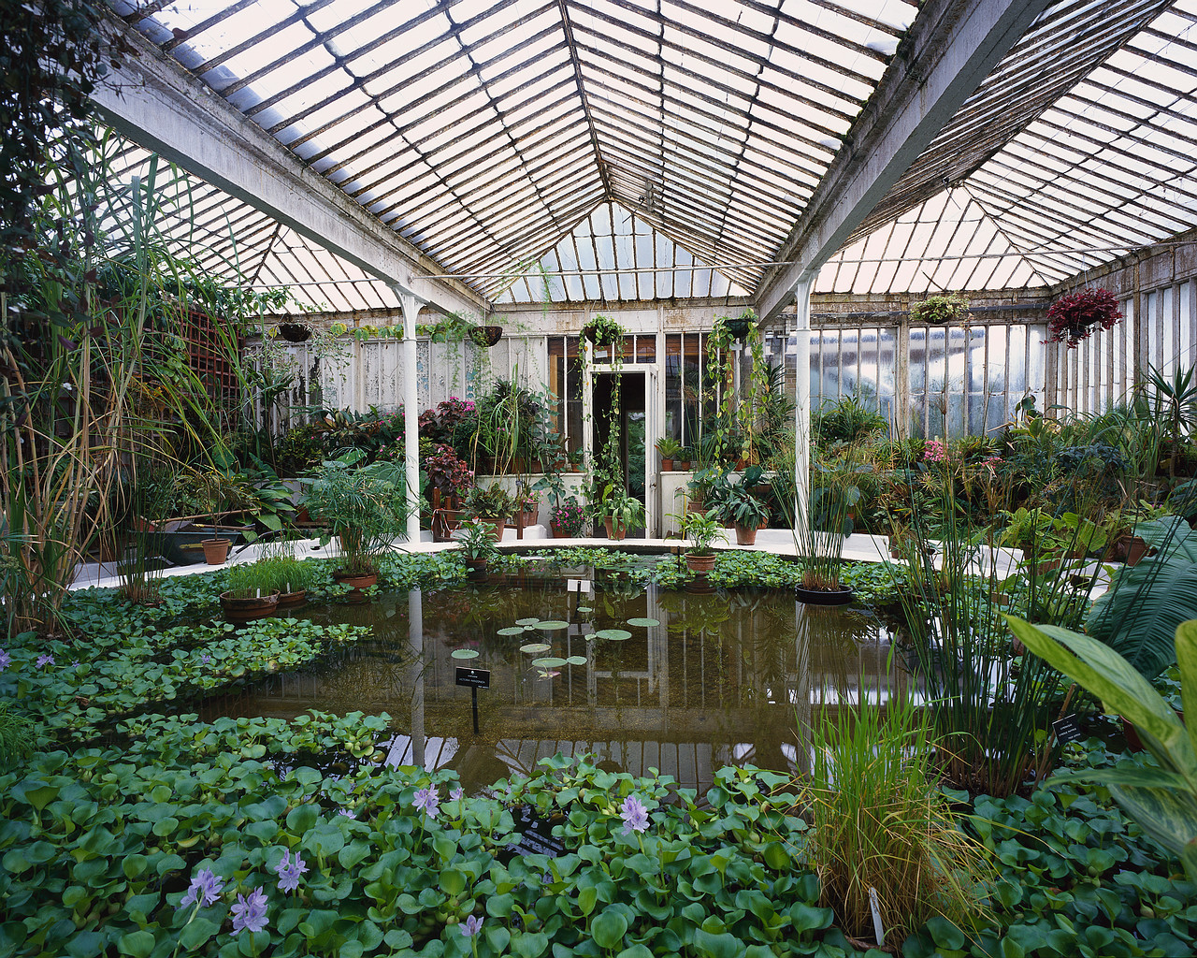
SPECIAL EVENTS:

September 9, 2012
Our meeting will be the second Sunday of September, September 9th at 2 pm and will be a greenhouse tour. Dan mumau’s dear mother has passed away, and he will not be participating in the tour. The first stop will be at the greenhouse of Al de ricco, 921 shifting sands drive off Washington between jones and rainbow. The second stop will be at the greenhouse of clarice and dennis dean ,
5540 santa margarita off rainbow. Attached to the email is a map that al made showing the locations of both homes. Al’s phone number 636-6732 and Clarice’s 876-2729. Food will be served at clarice’s house. Be sure to come to the greenhouse tour. Al and clarice will speak to you about how they built their greenhouses and how they solved the problems of light, temperature, humidity and air flow. (BYTHE WAY, THE PICTURE ABOVE IS OF MY GREENHOUSE…

IN MY DREAMS…)
Second Sunday
Greenhouse Tour
Al deRicco, Clarice Dean, Dan Mumau
October 7, 2012
Peter Lin
“Growing Specimen Orchids”
November 4, 2012
Carol Siegel “Liars and Cheats:
The Story of Orchid Deception”
December 2, 2012
Holiday Party
January 6, 2012
Ron Parsons
“Miniature Orchids”
February 3, 2013
Alan Kochs
“Unusual Species for the Cattleya
Grower”
March 3, 2013 Mike Glikbarg TBA
April 7, 2013 Karen Muir “Maxillaria”
May 5, 2013 Harry Phillips from Andy
Orchids TBA
June 2, 2013 Jason Fischer
“Australian Orchid Conference”
July 7, 2013 Diana Smith “Catasetum”
August 4, 2013 Barbecue
September 8, 2013
Greenhouse Tour
November 3, 2013 Carol Siegel
“Legends of the Orchid World”

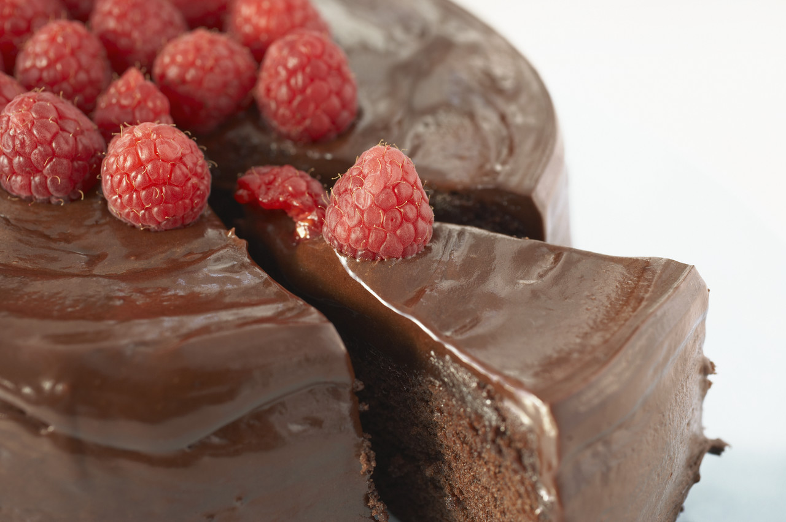

A CHOCOLATE BAR!

To celebrate our new location, I personally have hired Dennis O’Sullivan, a great piano player, to play from 1-2 as we set up and socialize for our October 7th meeting. I thought it would make the day. The club is paying for a Pizza Hut Pizza Party. I thought it would be fun if we had a CHOCOLATE BAR as well. I saw it at my nephew’s wedding, and everybody went crazy! Everyone is asked to bring something chocolate- a chocolate cake, chocolate candy, chocolate cookies, chocolate ice cream, chocolate mousse, chocolate-covered oreos, chocolate-covered strawberries, chocolate shoes, hot chocolate, chocolate-covered peanut butter- just about anything. Don’t you think that would be special! Gloria Gunn will provide drinks, ice and paper goods.
Our speaker is Peter Lin, who is a big favorite with our club. He will be speaking on growing specimen plants, those incredibly big, gorgeous plants that are covered with loads of blooms and grow super-big. There is a trick to growing these beauties (like not killing them when they are little…) and picking the right plants and grooming them properly. It should be very interesting. Peter Lin will bring plants to sell.
Remember we now meet at the rainbow library 3150 North Buffalo at the corner of Cheyenne in the Meeting Room. Turn right after entering the front door of the library.

PIANO MUSIC , PIZZA PARTY, AND A CHOCOLATE BAR FOR OUR OCTOBER 7TH MEETING…and Peter Lin!

OUR SINCEREST CONDOLENCES TO DAN MUMAU ON THE PASSING OF HIS BELOVED MOTHER. YOU ARE IN OUR THOUGHTS AND PRAYERS.

It is always fun to go to shows. The San Francisco Orchid Society has a big show in the winter, but this is their “small show.” You might like to go. Check it out on their website below.
Our August barbecue at the beautiful home of Eldine Stevens in Mt. Charleston was a big success. We really had fun, and the weather was gorgeous. We thank Eldine for allowing us to spend time in her cool mountain retreat. We especially thank Dan Mumau and Mike Lawless for catering the grand event, coming up the day before and bringing all the meats and decorations drinks, and getting up early to cook the feast for us. We thank Cathy Loftfield who gave a wonderful presentation on growing plants in sphagnum moss. We loved it. Ole Borresen and Tony Billitere schlepped free hotel plants up for us, yet made over $200 by selling other plants in advance. What a help!! We presented the DIAMOND AWARD OF EXCELLENT to Dan Mumau and Mike Lawless. Orchid Digest will print their names and information about their special contribution in a future issue. It is a coveted away and considered a great honor to be presented the Diamond Award for service to the orchid world. Surely these two men deserve it for their generous support of our club and their unending loyalty to us. BEST WISHES TO MYRA GLASSMAN ON HER
HAND SURGERY. WE LOVE YOU.
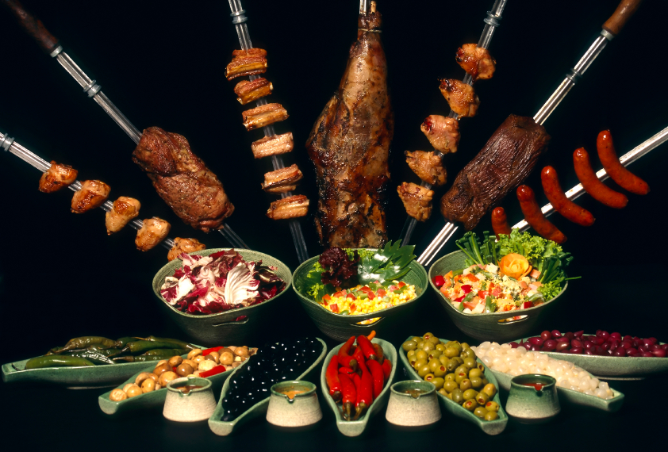

Photography by Ron Parsons

Plant and Flower enthusiasts alike are marking their calendars for the Orchids in the Park Sale & Exhibition show on the weekend of September 15 and 16, 2012. This all-day orchid park exhibition attracts many visitors with the lush setting in Golden Gate Park and the chance to marvel at the colorful orchids for sale and exhibition.

There are multiple ways to immerse yourself in this family-fun weekend event hosted by the San Francisco Orchid Society. There are demonstrations with respect to every aspect of orchid species and orchid care. Also, there are lectures about the plants with experts on orchids who will be speaking at these lectures. Finally, there will be raffles of highly prized orchid plants.

Who: The San Francisco Orchid Society

What: Orchids in the Park Exhibition and Sale

Where: San Francisco County Fair Building (Hall of Flowers) 9th Avenue & Lincoln Way, San Francisco, CA.

When: September 15 and September 16, 2012 10 AM- 5 PM

Tickets: General Admission $4, Seniors $3, Children under 16 free

More Information:
info@orchidsanfrancisco.org or http://www.orchidsanfrancisco.org/

National annd Internationally known vendors
American Horticultural Supplies
Andy's Orchids
Blossom Planting Supplies
Botanico
Brookside Orchids
Cal-Orchid
City College of San Francisco-
Environmental Horticulture and Floristry
D & D Orchids
Ecuagenera
Gold Country Orchids
Golden Gate Orchids
Hanging Gardens
Hamilton Orchids
J & L Orchids
Napa Valley Orchids
Orchids and Gardens
Orchid Design
Orchids of Los Osos
Paphiness Orchids
Seed Engei
San Francisco Orchid Society Members' Sales

ATTACHED TO THE NEWSLETTER IS AN ARTICLE I WROTE FOR ORCHID DIGEST THAT WAS PUBLISHED LAST MONTH ON CHIKANDA.

LOVE CAROL

