**THE GREATER LAS VEGAS ORCHID SOCIETY**

**THE ORCHID COLUMN**

# DECEMBER 2 ,2012 12:30 PM IT’S A PARTY AT MY HOUSE!

**CAROL SIEGEL, EDITOR**



**A packed crowd came to our meeting last month at the Rainbow Library (great room!). I enjoyed doing a presentation on orchid deception, a study in those great con men that we love to grow. We sold zygopetalum and enjoyed the great food provided by Carolyn Jones, Wanda LaFollette, Mary King, Joel Davidson, Liz Waters, Rosalie DeGuzman and their mates. Ole and Tony filled the room with marvelous hotel plants, and we made $200 on the raffle! I provided piano music by the great**

**Dennis Sullivan (**[**karennis1@yahoo.com**](mailto:karennis1@yahoo.com)**) which was just lovely.**

**We welcomed our guests Karin Fagan and her husband,**

**Esther Gesser, Tatiana Blum and Alvin York. Thanks, Alvin, for vacuuming after. We hope you will come to the holiday party next month and join us ever after that. We thank Myra Glassman for holding elections. Carol Siegel was elected president, Cathy Loftfield Vice-President, Eileen McKyton Secretary and Diana Smith Treasurer. We thank Roberta Schechter for her excellent service as VP. She and Fred are moving to California to be with their kids. We will miss you.**

**SPECIAL EVENTS:**

**December 2, 2012 Holiday Party**

We had great fun at our November meeting

**January 6, 2012**

**Ron Parsons “Miniature Orchids”**

**February 3, 2013**

**Alan Kochs “Unusual Species for the**

**Cattleya Grower”**

**March 3, 2013 Mike Glikbarg “One Dozen**

**Orchids for You to Grow”**

**April 7, 2013 Karen Muir “Maxillaria”**

**May 5, 2013 Harry Phillips from Andy**

**Orchids “Mounted Orchids”**

**June 2, 2013 Jason Fischer**

**“Australian Orchid Conference”**

**July 7, 2013 Diana Smith “Catasetum”**

**August 4, 2013 Barbecue**

**Sept 8, 2013 Greenhouse Tour**

**October 6, 2013 Cathy Loftfield**

**“Orchids of Guatemala”**

**November 3, 2013 Carol Siegel**

**“Orchidmaniacs- The Historical**

**Legends of the Orchid World”**

**December 3, 2013 Holiday Party**

**A million thanks to bruce and wanda Lafollette who paid our 6-month insurance bill ($213!!). how incredibly generous of you!**



**COME TO OUR HOLIDAY PARTY 12:30 Dec 2ndAt my house (1 ½ hrs. earlier than usual time)**

**We are excited about our Holiday Party to be held at my home on Sunday, December 2nd at 12:30 pm. Bring some canned goods or boxes of food for us to donate to the needy at the holidays. My house is 8601 Robinson Ridge Drive in Canyon Gate Country Club (which is opposite the Lakes) on Sahara between Durango and Ft. Apache. If you go west on Sahara, it is the first right after Durango (Canyon Gate Drive). There is a light. Make a right into the guard gate & say you are with the club. Make the firt right on Medalist and continue around for about a minute. The street, inexplicably, becomes Medalist, Iron Ridge and Robinson Ridge in a minute. The house has a stained glass shell door. Everybody will bring a dish- side dish, dessert, vegetable, main dish for 10-12 with serving spoons, heated and cut up if necessary. The following people have graciously signed up for meats:**

**Two Prime rib Dan Mumau, Mike Lawless, Carol Siegel**

**Eye round roast Gloria Gunn**

**Ham Betty and John Williams**

**Pork Loin Cathy Loftfield**

**Fish Wanda and Bruce LaFollette**

**Turkey Nita Bragg**

**Fried Turkey Joel Davidson**

**Shrimp Cathy Lindsay**

**I will provide paper goods, a margarita machine, champagne, drinks and wine and entertainment. Marty Silber will be on keyboard. We will have a lady putting tinsel in hair, a photo booth, a nail artist painting orchids on nails (guys, too!) , and lot of toys. I am excited! As is tradition the club will have a raffle where everyone will get a blooming orchids for $6.Remember if you have too many margaritas, we will put you in a cab and we will not let you drive. We love you! It is always the most fun, a chance for us to have fun together and celebrate another successful year. Every year people call me and ask if they can bring their mate, partner, relative or friend. SURE!! You don’t have to ask! We just ask that you bring an extra dish, side dish, main dish or dessert, so that we will have enough food for the extra people who come. We sell raffle tickets to the guests as well for $6, but our club members go into a special bucket so that they can choose first. Seems only fair… People also ask if they can have an holiday orchid reserved for them if they leave early from the party or don’t come. Holiday orchids are only available when we call the raffle tickets, and you must be at the party to get one. It avoids conflict. See you on Dec 2nd at 12:30.**

**DON’T FORGET TO BRING SOME CANS OR BOXES OF FOOD FOR THE NEEDY. WE COLLECT AND DONATE FOOD.**

MY GROWING AREA UNDER LIGHTS

When people come to orchid holiday party, they usually stop in my garage where I grow my orchids. I live in a gated community that, very meanly, does not allow greenhouses. I am usually having fun with everybody so I don’t have time to talk about the set-up. For someone wanting to grow under lights, you might look at how I have solved some problems of growing that way.

1.Water- I have a sink. Whenever possible, which is most of the time, I take each plant to the sink and water it for at least 15 seconds. When I am very busy, I use my hose which has adjustable spray. Both are connected to my de-ionized water tank which is changed every month by Marvel Water. I water once a week. If it is very hot, I will hose everything on another day. I do not do well with mounted plants.

2.Humidity- I have a hydrofogger from Hydrofarm. It is connected to my deionized unit as well. It is on a humidistat, and I try to keep the humidity at 60-70%. It works well. I change the water and clean it weekly.

3.Air movement- I have three big fans that run all the time. I used to have more little fans, but these three Vornado fans move a lot of air.

4.Temperature- I have a split air conditioner on the wall on a timer.

I usually have to use it from June to October. It is expensive but worth it to me. (My husband says he wants to come back as one of my orchids in his next life… Poor thing). I keep the temperature at 80-82 degrees in the summer which is cool enough. I have hung 6mm plastic to keep the a/c & humidity in. I never have to heat because the lights are warm. In the winter, the temperature drops at night to 58-60 degrees in November which initiates phal and paph blooms. I pull the plastic up in October to help get a cool evening for bloom initiation and put it down when it gets cold or hot. I have min/max temp thermometers to make sure I get it 10 degrees cooler at night

5.Light- I bought light carts from Hydrofarm (no longer available but other brands are) ten years ago. I have nine carts. I put 40 watt Agrosun Gold

(4 bulbs) in a fluorescent fixture on the bottom for phals and some paphs.

I have Teklite fixtures on the top with 4-8 T5 bulbs for high light plants. The 8-bulb units are for cattleyas. I change my bulbs once a year on a staggered time schedule. I buy my bulbs from [www.4hydroponics.com](http://www.4hydroponics.com). Jay Lawrence gives me a discount. My bulbs are on a timer which varies with the season- 11 hours now up to 16 to 18 hours in the summer to mimic nature.

ON NOVEMBER 4TH, I AM GOING TO SPEAK ON ‘LIARS AND CHEATS: THE STORY OF ORCHID DECEPTION.’ IT IS THE FASCINATING TALE OF

ORCHIDS WHERE THE REWARD GIVEN IS OFTEN JUST A DECOY AND NOT THE REAL MCCOY. 85% OF THE DECEIT FLOWERS IN THE WORLD ARE ORCHIDS, AND LYING HAS BECOME SOMETHING OF AN ORCHID FAMILY SPECIALTY. WHETHER IT IS LYING ABOUT HAVING NECTAR OR BEING A GOOD PLACE TO LAY EGGS OR A WILLING FEMALE, ORCHIDS ARE THE BEST BOTANICAL CHEATS IN THE WORLD. IN AUSTRALIA, NEARLY ALL THE TERRESTRIAL ORCHIDS ARE **LIARS, AND IN PLACES LIKE EUROPE, NORTH AFRICA, AND THE MIDDLE EAST, OVER HALF OF THE ORCHIDS ARE FRAUDS.**

**The**

**THE ORCHID GROWER’S CHRISTMAS (WITH APOLOGIES TO CLEMENT C. MOORE)**

**Twas the night before Christmas, and in the greenhouse**

**Not a creature was stirring (neither slug, scale, nor mouse),**

**The seedlings were tucked in their compots with care,**

**In hope that some flower spikes soon would be there;**

**And I had just put on my coat, boots and cap**

**To check out the greenhouse before taking a nap,**

**When up on the roof I heard such a clatter**

**I looked through the pop-up to see what was the matter.**

**Then what should appear to my wondering eyes**

**But Santa Claus, dressed like Magnum P.I.**

**In surfer shorts, sandals and print shirt so bold-**

**I couldn’t help asking, “Come in. Aren’t you cold?”**

**He slid down the heater pipe, just missing the flue,**

**Sat down on the bench and said, “Don’t mind if I do!**

**It’s ben a long flight, and I’m just a bit tired.”**

**“But where are your reindeer?” “Oh, they’ve all been fired.**

**They went out on strike with the elves and the rest.**

**So this year, I just sent all my stuff UPS-**

**Except for the orchids-wouldn’t want them to freeze**

**Nice phals you’ve got here.” (He paused for a sneeze**

**And to look at a brasso way up on the shelf.)**

**“ I think they’re terrific but can’t grow them myself.**

**It seems that my greenhouse is simply too cold.”**

**I gasped, “You grow ORCHIDS up at the North Pole?”**

**“Well, of course! Have for years!” replied old St. Nick,**

**“Though getting those big cats to bloom’s quite a trick,**

**And that dim northern sun tends to shorten most spikes.**

**Now, I’ve got something here in my sack that you’d like!”**

**He pulled out a Vanda, a big husky fellow,**

**And said, “It’s my guess that this should be a yellow.”**

**Then he jumped through the pop-up and into his sled.**

**“But who knows? Coming from Santa, it just might be red!”**

**And I heard him exclaim as he drove out of sight,**

**“Blooming orchids to all, and to all a good night!”**

**Elaine Cantwell**

**More below…**

**I****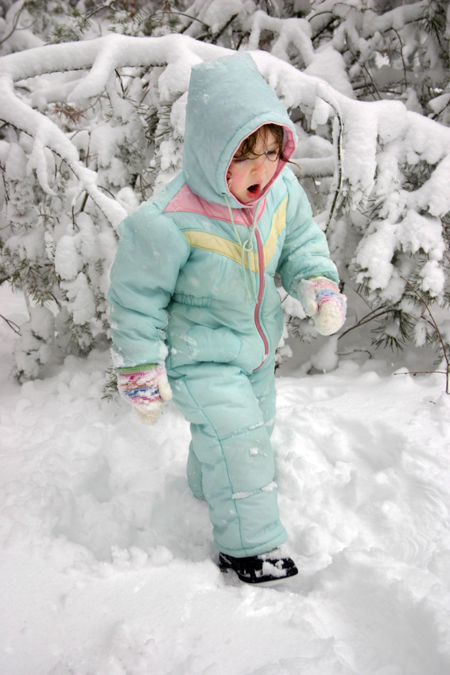**

MORE BELOW…

WHITE ELEPHANT SALE IN JANUARY…

**It’s time once more for our annual white elephant sale, JANUARY 6th, an event that earned OVER $1000 last year. COME EARLY SO YOU CAN SET UP AND BROWSE AND BUY. ONE O’CLOCK WOULD BE GOOD! We are a very high-class club, and our junk is of the very best quality. Everyone brings in some unwanted treasure- wine, a holiday gift, a lamp, a bike, books, CD’s, VHS’s, DVD’s, dishes, pictures, nick nacks, sporting equipment, food…Don’t have anything elephantine? Bring an orchid or orchid stuff or a division from your collection or Home Depot. I bought orchids that I am going to donate. You could, too. Start looking around. I will write to our friends at orchid nurseries and try to get them to donate orchids to us for our sale. Last year, I got over 80 for our cause. We are considering have a raffle for an IPad mini or flat-screen TV.Because we have no storage space at the Rainbow Library, we have decided to sell our library book at the White Elephant Sale. It will be your opportunity to get high-quality orchid books at a fraction of the price—and help out the club as well.**

**Ron Parsons will be doing a power point presentation in January on miniature orchids. He is writing a book on the subject and is just a fabulous photographer. He will also be selling plants. Thanks to Terry Wilsey for doing his travel arrangements.**

C:\Documents and Settings\Rick\Local Settings\Temporary Internet Files\Content.IE5\VKQHUYPQ\MC900441570[1].wmfSee you December 2nd

12:30 pm. Enjoy your Thanksgiving. Love Carol

254-4168 cell 525-3714